INFOSYS SPRINGBOARD
TEAM ONE
━━━━━━━━━━━━━━━━━━━━━━━━━━━━━━
PROJECT DOCUMENTATION REPORT
REAL ESTATE
DUE DILIGENCE AGENT
A secure, data-driven platform for property search, due diligence,
risk assessment, comparable analysis and professional report generation.
PROPERTY • RISK • MARKET ANALYSIS • REPORTING
TECHNOLOGY
React • Java 21 • Spring Boot • PostgreSQL • Docker
PREPARED BY
TEAM ONE
Infosys Springboard Team Project
────────────────────────────
ACADEMIC PROJECT • 2026

1. Title & Objective

1.1 Title
Real Estate Due Diligence Agent

1.2 Objective
The objective is to develop an enterprise-oriented real estate due-diligence platform that enables buyers, sellers, agents, legal reviewers, and financial institutions to evaluate a property from a centralized interface. The system reduces repetitive manual research by organizing property information, ownership-related information, tax, zoning, flood, permit and environmental attributes, risk indicators, market comparisons, documents, and report history within a common workflow.

1.3 Key Outcomes
- Centralized property due-diligence workspace with persistent PostgreSQL records.
- Secure registration, email verification, password authentication, JWT authorization and Google OAuth2 support.
- Role-based access for BUYER, SELLER, AGENT, LEGAL_REVIEWER and BANK.
- Property search/details workflow with structured address and due-diligence information.
- Risk assessment using persisted risk categories and property-level risk records.
- Comparable-property analysis using backend market-analysis data rather than fabricated client-side values.
- Persisted due-diligence reports with server-side PDF and Excel generation.
- Notifications, watchlists, offers, inquiries, documents and audit/history workflows.
- Dockerized runtime with PostgreSQL, Spring Boot backend and Nginx-served React frontend.

2. Architecture Components & Technical Design
The implemented system follows a layered web architecture. The React client communicates with Spring Boot REST controllers. Spring Security protects endpoints and applies role-based authorization. Service classes implement business rules and persistence is handled through Spring Data JPA against PostgreSQL. Report services assemble stored property information, risk information and comparable information into PDF and Excel outputs.
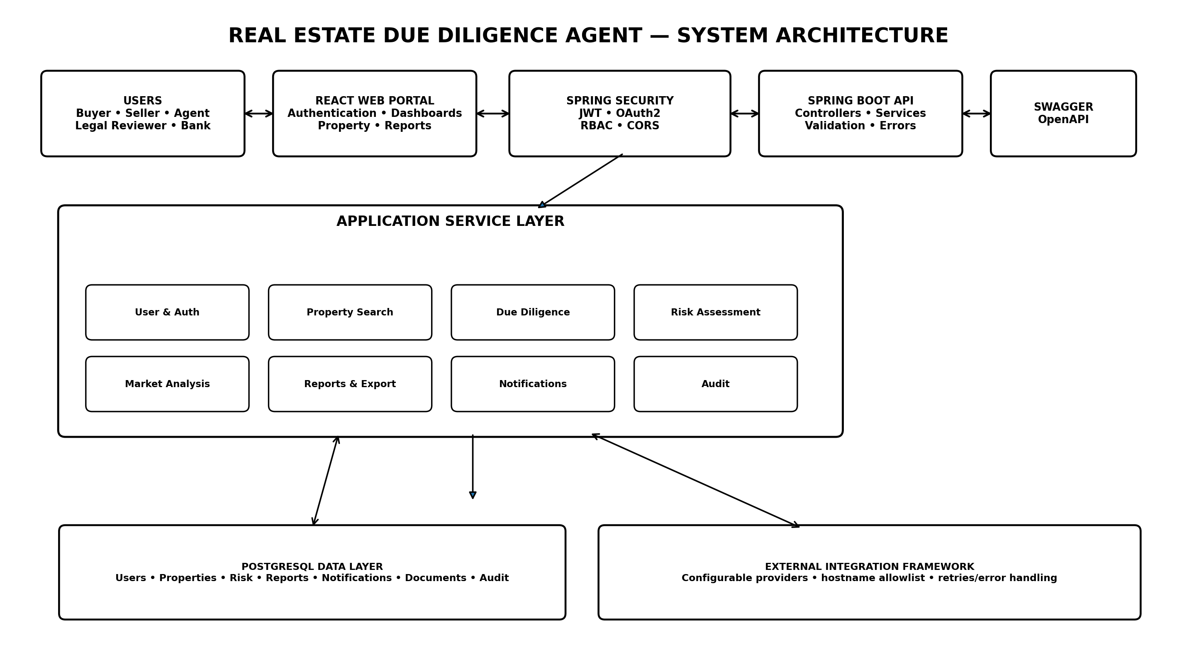
Figure 1. Implemented logical system architecture.

2.1 Architectural Layers
LAYER | RESPONSIBILITY | IMPLEMENTED TECHNOLOGY
Presentation | Dashboards, property views, forms and report downloads | React, JavaScript
Security | Authentication, role checks, protected routes and API authorization | Spring Security, JWT, OAuth2
API | REST controllers, validation and HTTP responses | Spring Boot, Spring MVC
Business | Property, risk, market, report, notification and audit workflows | Java service layer
Persistence | Entity mapping and repository operations | Spring Data JPA, Hibernate, PostgreSQL
Integration | Configurable providers and safe endpoint validation | HTTP integration services
Reporting | Server-side document generation | OpenPDF, Apache POI
Runtime | Containerized frontend, backend and database | Docker, Docker Compose, Nginx

2.2 Logical Entity Relationship View
The logical model below shows the main domain objects used by the application. It is a documentation-level relationship view rather than a claim that every relationship is a separate database table.
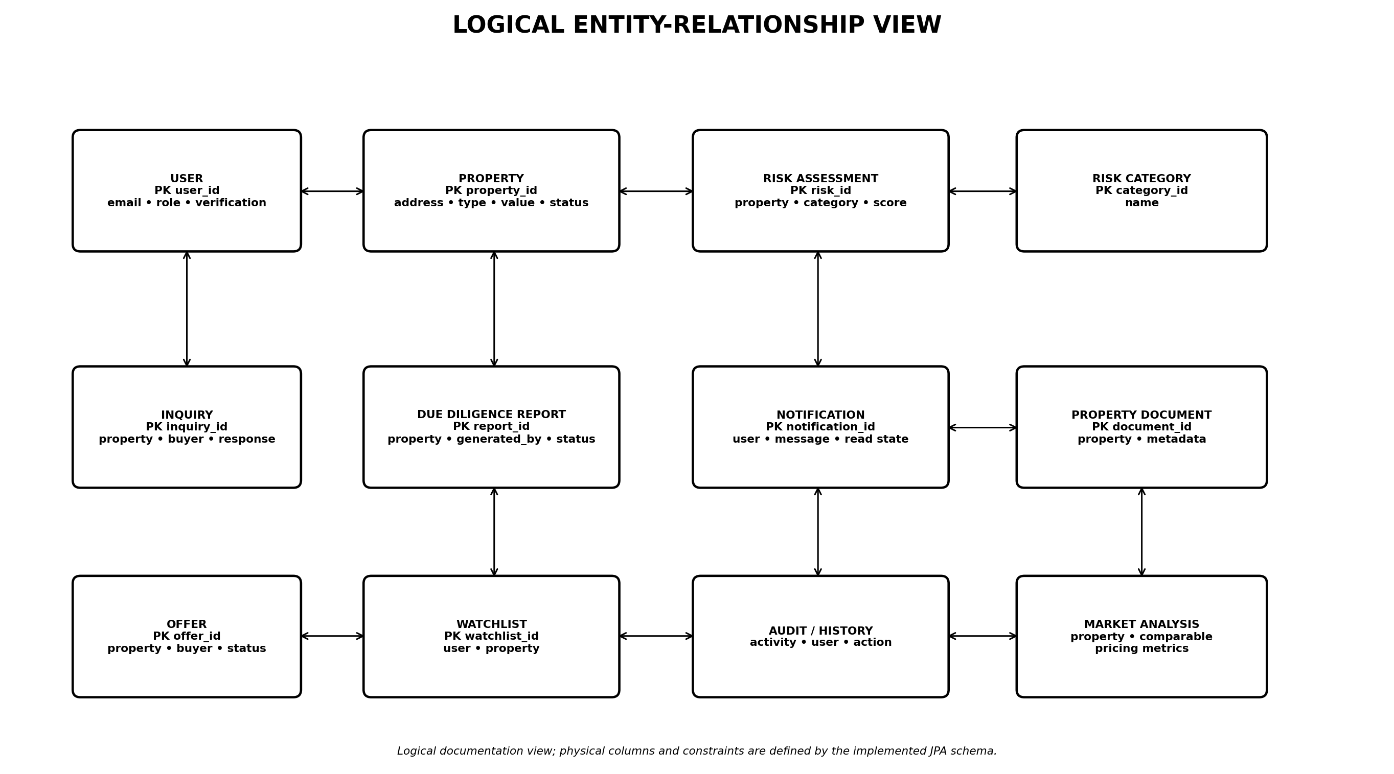
Figure 2. Logical domain/ER view used for the project documentation.

2.3 Control Flow / Component Interaction
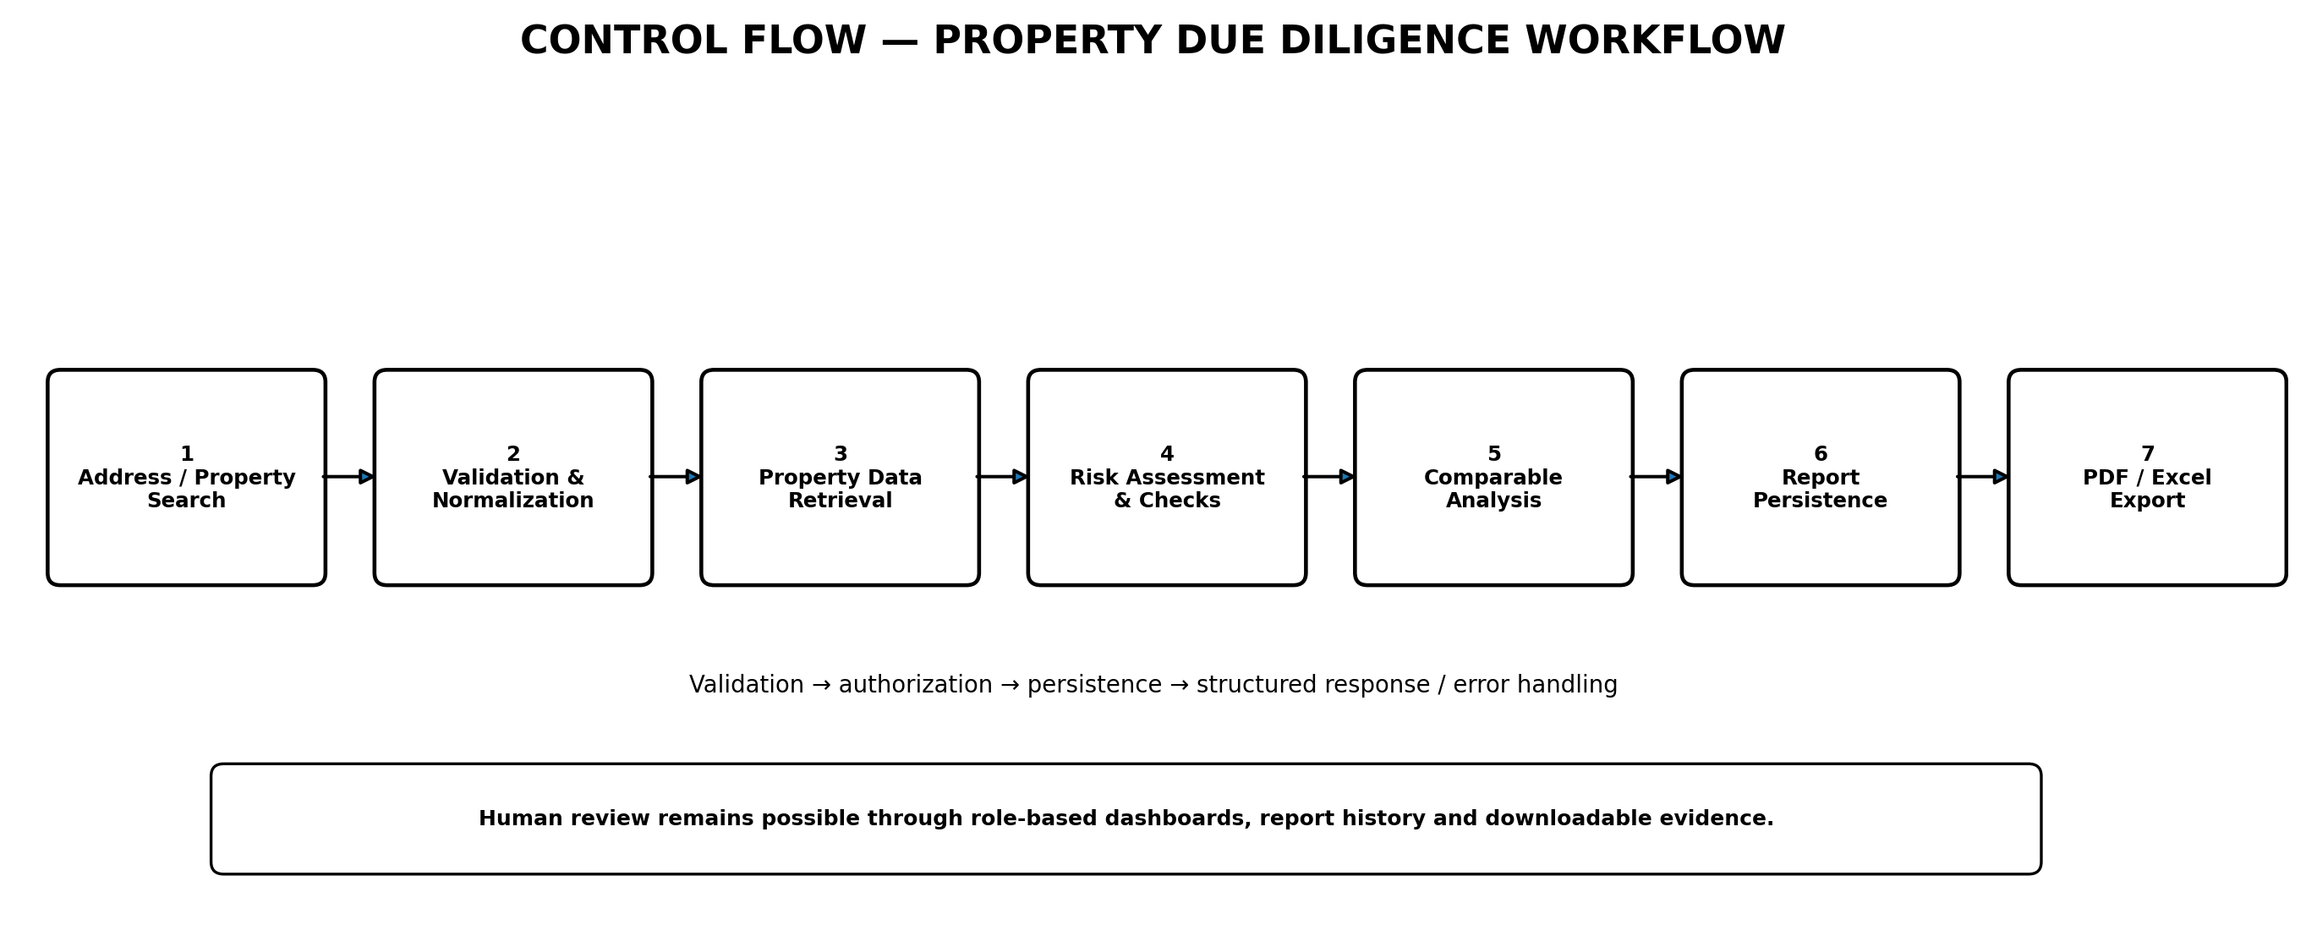
Figure 3. End-to-end property due-diligence control flow.

2.4 Data Flow Diagram
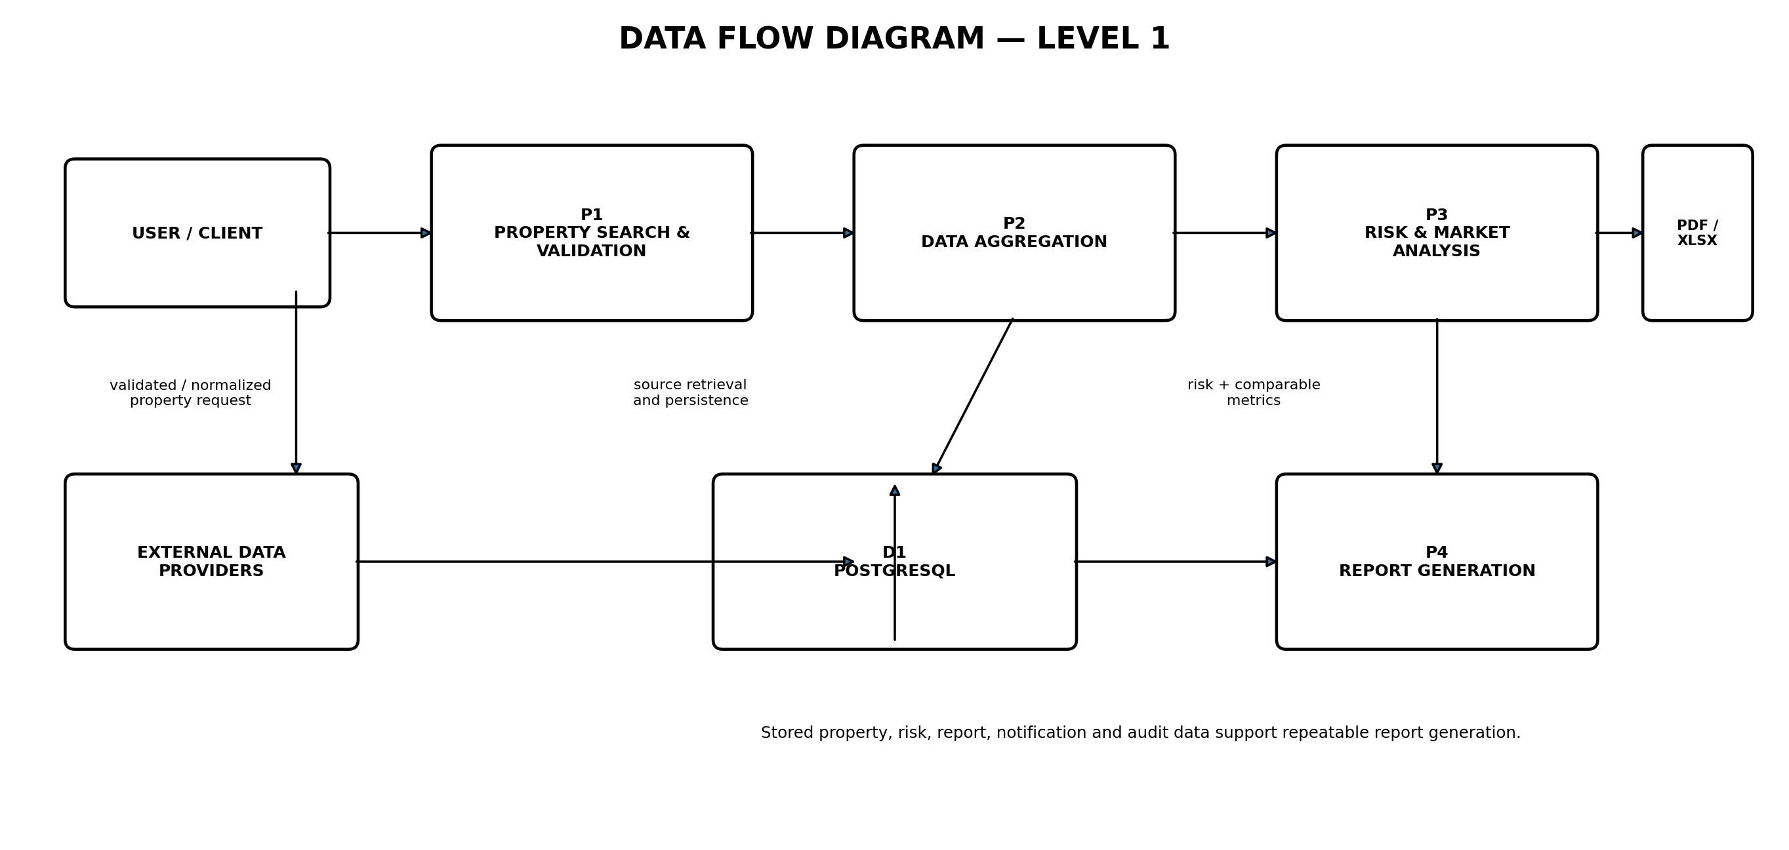
Figure 4. Level-1 data flow for property aggregation, analysis and reporting.

3. Modules

1. User Management
- Registration and login
- Email verification and password recovery
- JWT and Google OAuth2 authentication
- Role-based access control
- User profile and role-aware dashboards
The current release supports BUYER, SELLER, AGENT, LEGAL_REVIEWER and BANK. The administrator role shown in the mentor template is not part of the current implemented role set.

2. Property Search Module
- Property search and selection
- Address validation and normalization
- Property details and history views
- Role-aware property workflows
The module provides the entry point for the due-diligence process and feeds the selected property into risk, market-analysis and report workflows.

3. Due Diligence Module
- Ownership information
- Tax information
- Zoning attributes
- Flood information
- Permit information
- Environmental information
- Utility-related information
- Document association
Due-diligence attributes are organized and persisted so that the user can review a property without switching between multiple application areas.

4. Risk Assessment Module
- Risk categories
- Property-level risk assessments
- Risk score display
- Legal/tax/flood/permit/zoning checks
- Role-protected risk updates
Risk data is read from the backend property-risk endpoint. Synthetic fallback scores were removed from the frontend.

5. Comparable Property Module
- Comparable-property retrieval
- Benchmark/average calculations
- Price variance
- Premium/discount interpretation
- Market-analysis view
The frontend consumes the backend market-analysis endpoint and presents explainable metrics. Fabricated distance and match-score values were removed.

6. Report Generation
- Persist report metadata
- Executive summary and overall risk score
- Server-side PDF generation
- Server-side Excel generation
- Property-level and report-level downloads
PDF reports use OpenPDF. Excel workbooks use Apache POI. The workbook contains five sheets: Property Overview, Risk Assessment, Market Comparables, Zoning & Compliance, and Tax History.

7. Notification Module
- Report-ready notifications
- Read/unread state
- User-scoped notification access
- Property-related alerts and preferences
Notification queries and mutations are scoped to the authenticated user to prevent cross-user access.

8. Audit Module
- Activity history
- Report history
- API/application logs
- User activity tracking
The audit layer supports traceability of important actions and complements role-based security and report history.

4. Week-wise Module Implementation

Milestone 1: Week 1 & 2 — Project Initialization, Design Process & Core Setup

Tasks
(1) Gather functional and non-functional requirements.
(2) Design system architecture and PostgreSQL domain model.
(3) Create UI workflows and role-specific application structure.
(4) Set up Spring Boot and PostgreSQL.
(5) Implement registration, login, email verification and JWT authentication.
(6) Implement Google OAuth2 login.
(7) Implement role-based authorization for the five current roles.
(8) Build property search/address workflow and integration framework.

Outcomes
(1) Core architecture established.
(2) Authentication and authorization implemented.
(3) Property workflow established.
(4) Database persistence and API structure operational.

Milestone 2: Week 3 & 4 — Property Information Aggregation & External Integrations

Tasks
(1) Implement property service and property details.
(2) Organize ownership and due-diligence information.
(3) Implement tax, zoning, flood, permit and environmental data handling.
(4) Persist property information in PostgreSQL.
(5) Add external integration framework, provider validation and error handling.
(6) Prevent unsafe arbitrary external provider URLs using exact hostname allowlisting.

Outcomes
(1) Structured property information available.
(2) Reliable persistence and controlled integration framework.
(3) Security and exception handling improved.

Milestone 3: Week 5 & 6 — Risk Assessment, Report Generation & Notifications

Tasks
(1) Implement risk categories and property-level risk assessments.
(2) Implement backend market-analysis/comparable workflow.
(3) Persist due-diligence reports.
(4) Generate PDF using OpenPDF.
(5) Generate Excel using Apache POI.
(6) Expose report-level and property-level export endpoints.
(7) Complete notifications, watchlist, inquiry, offer and document workflows.
(8) Add report history and role-aware report access.

Outcomes
(1) Risk workflow completed.
(2) Comparable analysis uses real backend data.
(3) PDF and Excel exports verified.
(4) Report history and notifications integrated.

Milestone 4: Week 7 & 8 — Testing, Deployment & Documentation

Tasks
(1) Run unit and integration tests.
(2) Validate end-to-end business workflows.
(3) Test security and error handling.
(4) Verify frontend production build.
(5) Containerize backend, frontend and PostgreSQL.
(6) Validate Docker runtime.
(7) Prepare final documentation and user/API documentation.
(8) Prepare application for AWS/Azure deployment.

Outcomes
(1) 33/33 backend tests passed.
(2) 12/12 frontend tests passed.
(3) Production frontend build succeeded.
(4) Docker services verified healthy.
(5) Cloud deployment remains the final environment-specific step.

5. Evaluation Criteria & Verification

Milestone 1 (Week 2)
(1) Project initialization and architecture completed.
(2) Authentication and role-based access implemented.
(3) Property search/address workflow functional.
(4) Database persistence established.

Milestone 2 (Week 4)
(1) Property information aggregation implemented.
(2) Ownership/tax/due-diligence data workflows available.
(3) Zoning, permit and flood attributes supported.
(4) External integration framework validated.

Milestone 3 (Week 6)
(1) Risk assessment engine completed.
(2) Comparable analysis implemented.
(3) Due-diligence report persistence functional.
(4) PDF and Excel generation verified.
(5) Notification/report-history workflows integrated.

Milestone 4 (Week 8)
(1) Integration and workflow testing completed.
(2) Security/error-handling checks completed.
(3) Frontend production build completed.
(4) Docker runtime validated.
(5) Documentation prepared.
(6) AWS/Azure deployment remains environment-specific pending work.

5.1 Test Summary
TEST AREA | RESULT | COUNT | DETAIL
Backend automated tests | PASS | 33 / 33 | Authentication, registration, authorization, API integration, notifications and report/export integration
Frontend tests | PASS | 12 / 12 | API/client workflow and registration-related coverage
Frontend production build | PASS | Success | React production build completed
Docker runtime | PASS | Healthy | PostgreSQL, Spring Boot backend and Nginx frontend verified
End-to-end report workflow | PASS | 10 / 10 | Login → property → report → PDF → Excel → property exports → risk/comparable data

5.2 Report Export Endpoints
METHOD | ENDPOINT | PURPOSE
POST | /api/reports | Create and persist a due-diligence report
GET | /api/reports | List accessible reports
GET | /api/reports/property/{propertyId} | List reports for a property
GET | /api/reports/{id}/pdf | Download server-generated PDF
GET | /api/reports/{id}/excel | Download server-generated Excel
GET | /api/reports/property/{propertyId}/pdf | Generate/download property-level PDF
GET | /api/reports/property/{propertyId}/excel | Generate/download property-level Excel

6. Java Tech Stack

Backend
- Java 21
- Spring Boot
- Spring MVC
- Spring Security
- Spring Data JPA
- Hibernate

Frontend
- JavaScript
- ReactJS
- Create React App-based frontend

Database
- PostgreSQL

Authentication
- JWT
- OAuth2 / Google OAuth2
- Email verification

Libraries & APIs
- OpenAPI / Swagger
- Lombok
- MapStruct
- OpenPDF 2.0.3
- Apache POI 5.3.0

Infrastructure
- Docker
- Docker Compose
- Nginx
- AWS/Azure deployment target
Conformance note: the mentor template lists Next.js, Tailwind CSS, Redis, GitHub Actions and JasperReports/iText. The current implementation documented here uses React, PostgreSQL, Docker/Nginx and OpenPDF/Apache POI instead. Only technologies actually verified in the project are presented as implemented.

7. Performance, Quality, Challenges & Deployment

Property Search Performance
(1) Property search response time.
(2) Address validation accuracy.
(3) Property data retrieval success rate.

External Data Integration
(1) Public-record retrieval success rate.
(2) External API response time.
(3) Data synchronization reliability.
(4) Failed API request recovery rate.

Due Diligence Performance
(1) Report generation time.
(2) Risk assessment completion rate.
(3) Property comparison processing time.
(4) Document generation success rate.

System Performance
(1) API response time.
(2) Concurrent user handling capacity.
(3) Database query performance.
(4) Cache hit ratio where caching is introduced.

Security & Audit Performance
(1) Authentication success rate.
(2) Unauthorized-access prevention.
(3) Audit log completeness.
(4) Security event monitoring efficiency.

Reporting & User Experience
(1) Report download success rate.
(2) Notification delivery success rate.
(3) User request completion time.
(4) Overall usability and user satisfaction.

7.1 Quality & Security Measures
- Role checks are enforced at backend endpoints; frontend route guards are a usability layer, not the final security boundary.
- Notification reads/deletes are scoped to the authenticated user.
- Buyer-only offer/inquiry operations are protected.
- Seller/agent inquiry responses are restricted to inquiries belonging to their properties.
- Report/document mutations are restricted to appropriate professional roles.
- Risk and verification mutations are role restricted.
- Google login no longer accepts caller-supplied identity claims.
- External integration URLs are validated against an exact hostname allowlist.
- Validation and global exception handling provide structured HTTP error responses.

7.2 Challenges & Resolutions
CHALLENGE | RESOLUTION
Email/SMTP configuration | Local SMTP credentials were not available. Registration was adjusted so mail delivery unavailability does not break the transaction; production can use a real SMTP provider.
Database schema consistency | Risk-category and property schema mismatches were traced and entity mappings, initialization and the test profile were aligned.
Report generation reliability | Initial report/PDF failures were traced through integration tests and service-layer corrections; final PDF and OOXML Excel outputs were verified.
Frontend data integrity | Hardcoded comparable values and unsafe object rendering were removed; screens now consume backend data.
Container environment | Docker resource/build issues were resolved and the packaged backend, Nginx frontend and PostgreSQL runtime were validated.

7.3 Deployment Status
The application has been containerized and verified as a three-service runtime: PostgreSQL for persistence, Spring Boot for the backend API, and an Nginx-served React production build for the frontend. The mentor requirement identifies AWS/Azure as the cloud target. Cloud deployment is therefore documented as the next environment-specific activity rather than being falsely reported as already completed.

8. Project Evidence & Presentation Checklist
For the final submission, capture the following HD screenshots from the verified application. The evidence order follows the mentor's module-oriented documentation format.
EVIDENCE | SCREENSHOT TO CAPTURE
Figure A | Login / registration and email-verification flow
Figure B | Buyer dashboard showing live database-backed property data
Figure C | Seller dashboard and property management
Figure D | Agent dashboard and inquiry/report workflow
Figure E | Legal Reviewer dashboard and reports
Figure F | Bank dashboard and report exports
Figure G | Property details page with due-diligence sections
Figure H | Risk assessment screen with persisted risk categories
Figure I | Comparable-property / market-analysis screen
Figure J | Generated PDF report layout
Figure K | Generated Excel workbook / sheets
Figure L | Docker containers / deployment runtime

8.1 Key Code Snippets for Final Submission

Security / role protection
@PreAuthorize("hasAnyRole('AGENT', 'LEGAL_REVIEWER', 'BANK')")

Report creation
POST /api/reports → persist report metadata → return reportId

PDF export
GET /api/reports/{id}/pdf → aggregate persisted data → OpenPDF → application/pdf

Excel export
GET /api/reports/{id}/excel → build workbook → Apache POI → application/vnd.openxmlformats-officedocument.spreadsheetml.sheet

Comparable analysis
GET /api/market-analysis/property/{propertyId} → benchmark metrics → frontend presentation

Risk analysis
GET /api/risk-assessments/property/{propertyId} → persisted risk records → risk UI

8.2 Final Conclusion
The Real Estate Due Diligence Agent brings authentication, property search, due-diligence information, risk assessment, comparable-property analysis, notifications, audit history and report generation into one application. The project has progressed from architecture and database setup through the core functional milestones and has been validated with automated tests, production frontend build checks, Docker runtime checks and an end-to-end report/export workflow. The remaining deployment activity is the environment-specific AWS/Azure setup, followed by final screenshot capture and submission packaging.

Project Evidence — Screenshots
High-definition application screenshots documenting the implemented login, dashboards, due-diligence, risk, market-analysis, reporting and runtime workflows.
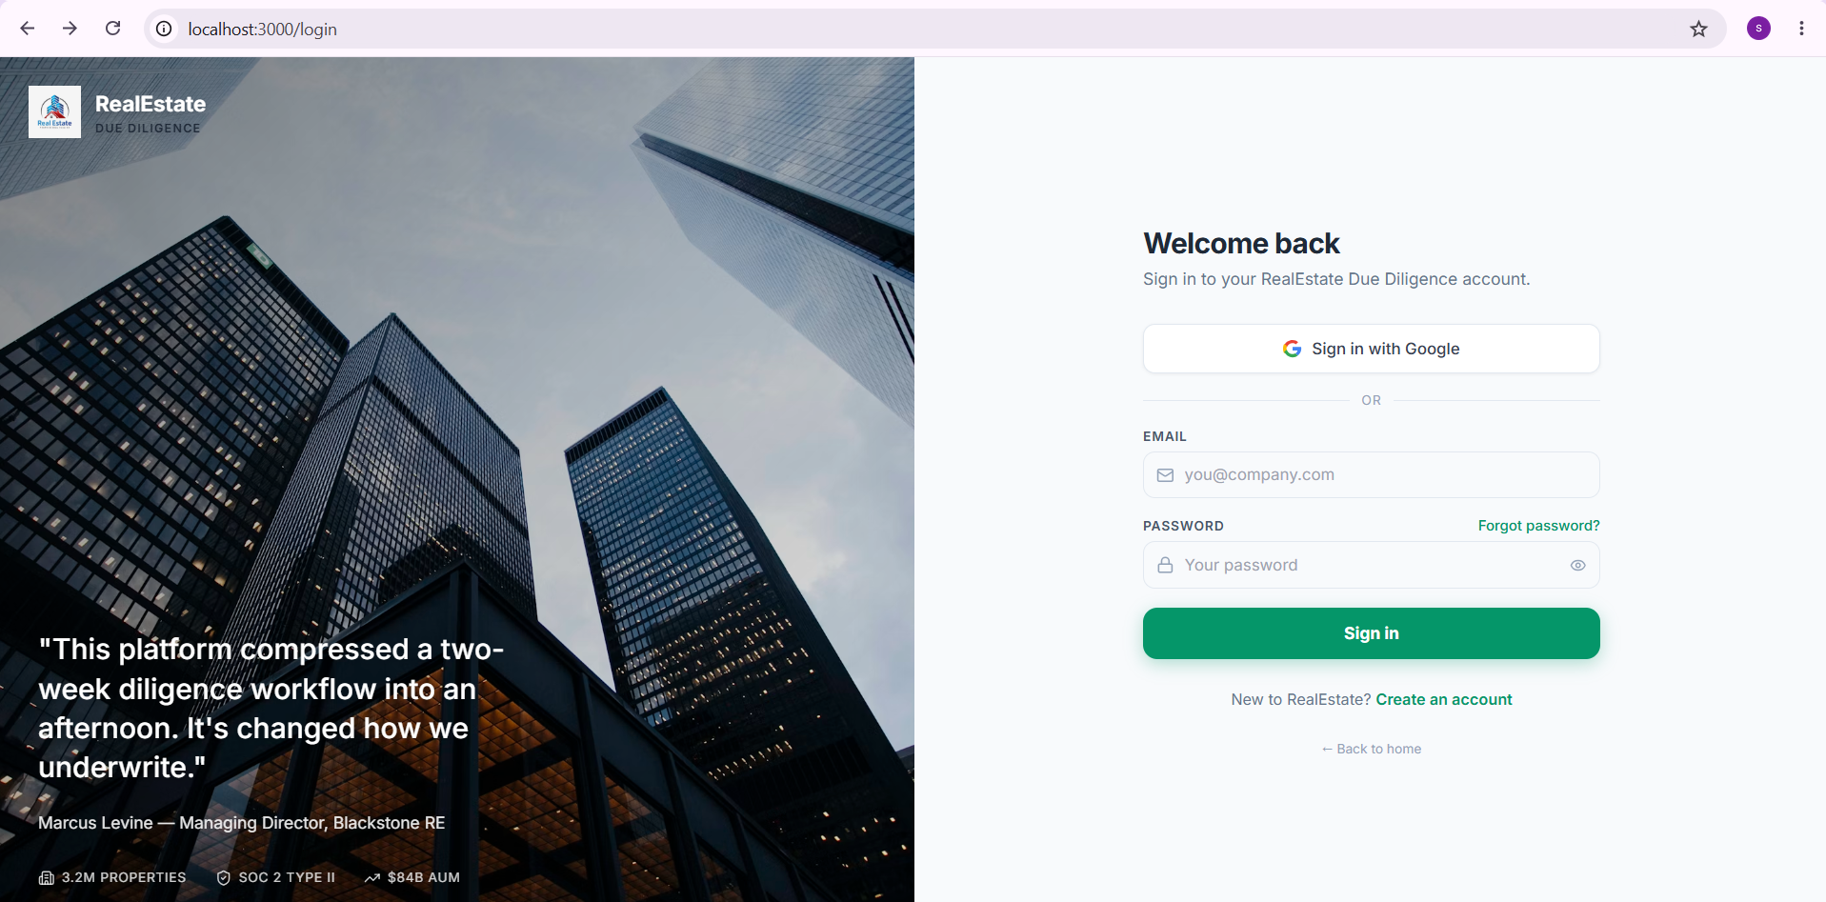
Figure 5. Real Estate Due Diligence Agent login and Google OAuth2 entry point.
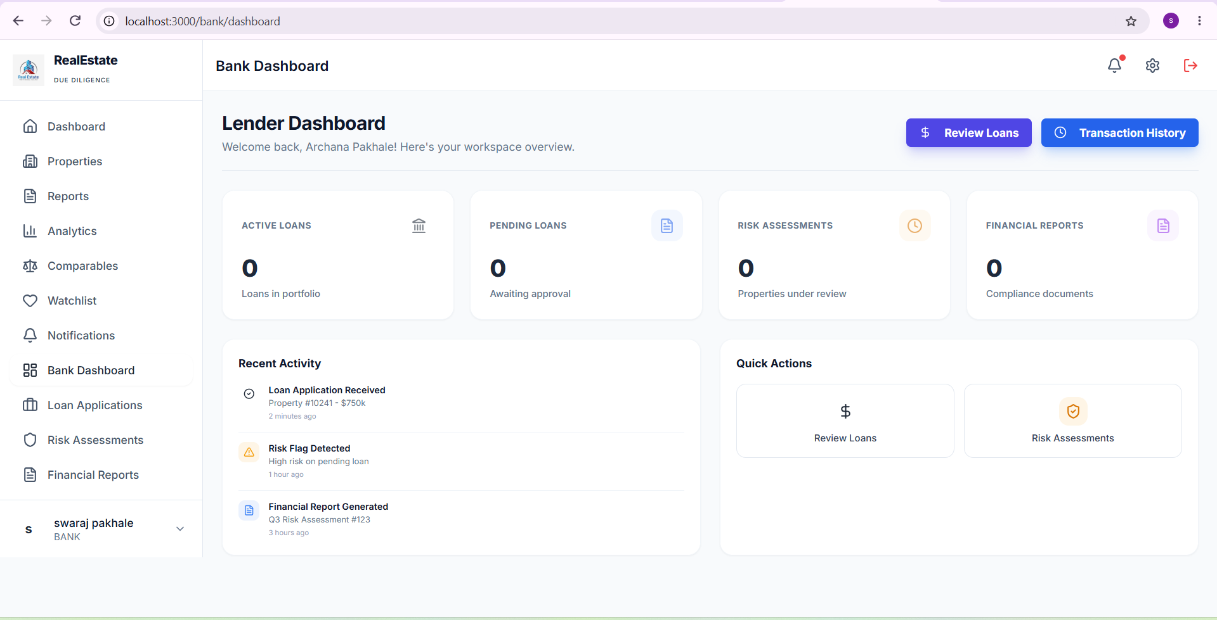
Figure 6. Bank dashboard with portfolio, risk-assessment and report views.
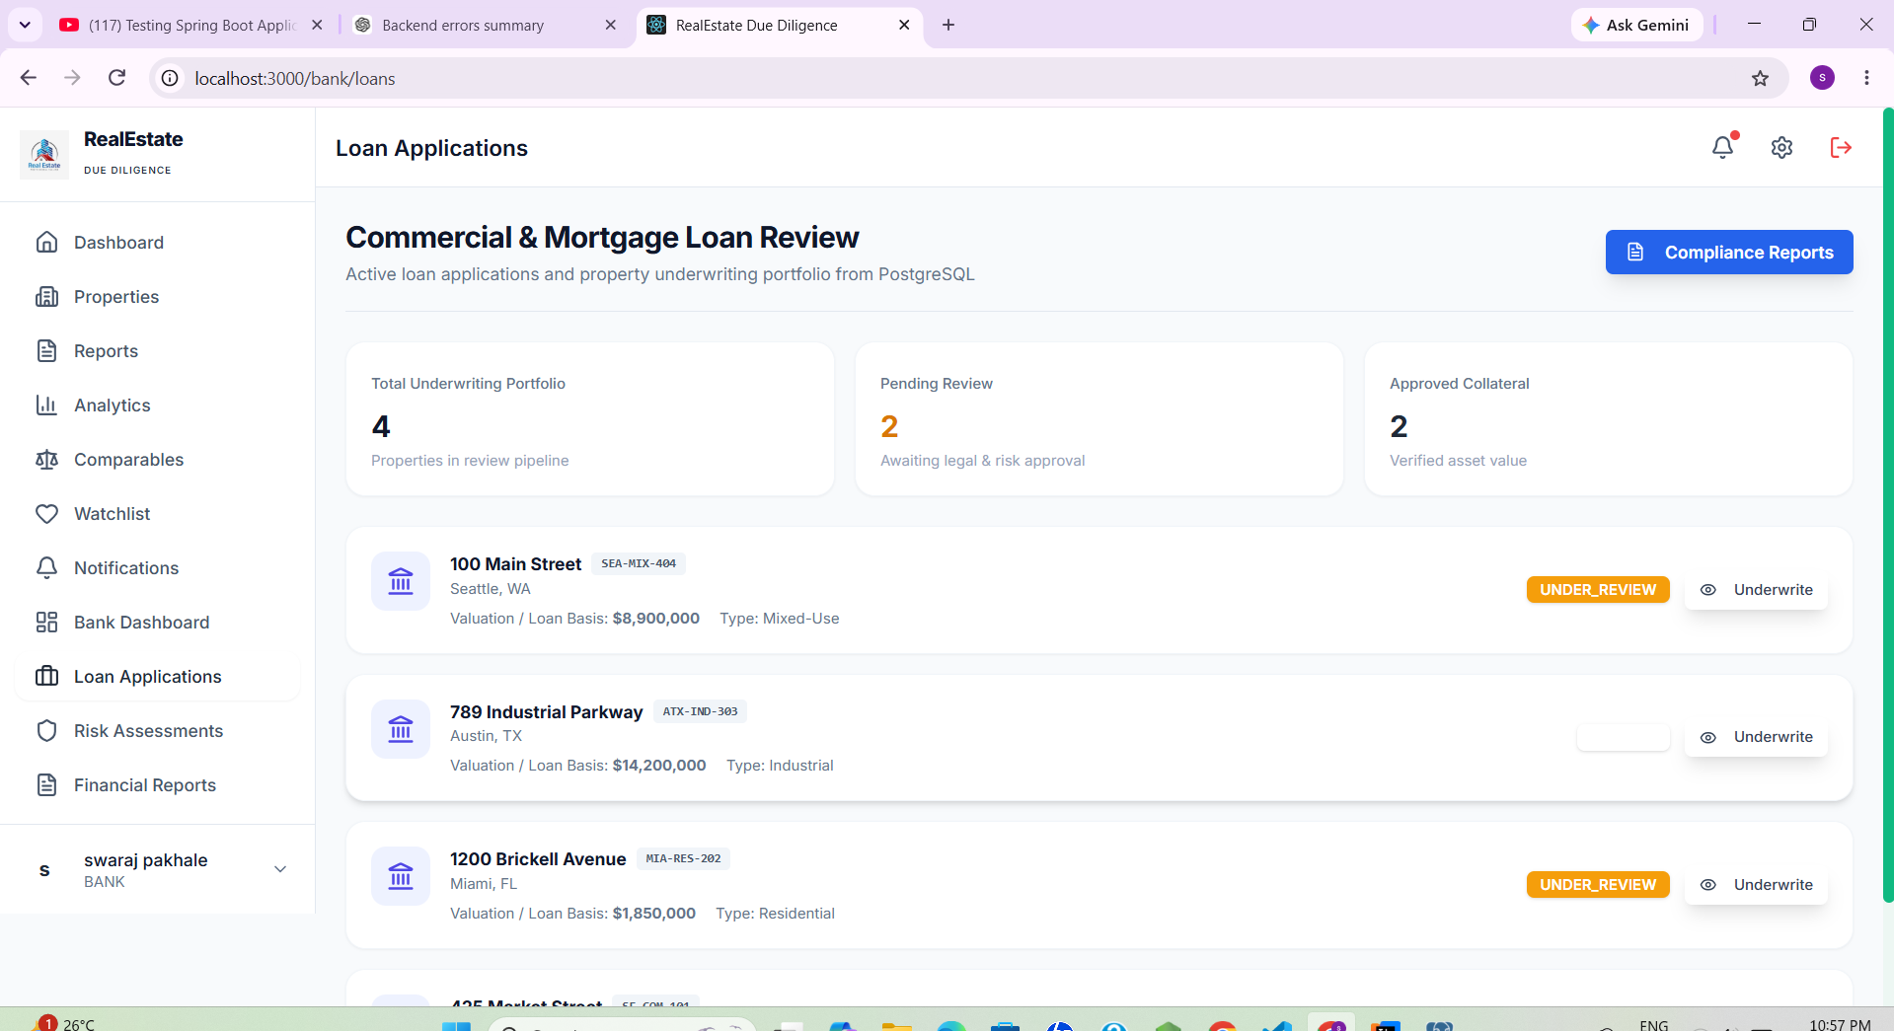
Figure 7. Commercial and mortgage loan review / underwriting dashboard.
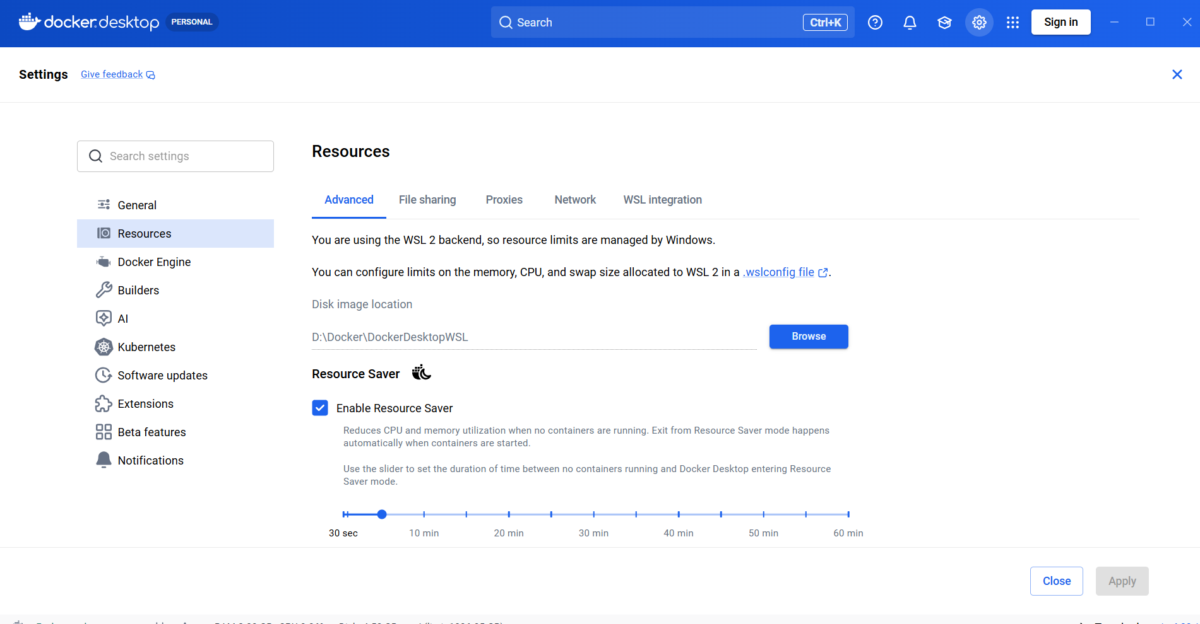
Figure 8. Risk-assessment / property review workflow evidence.
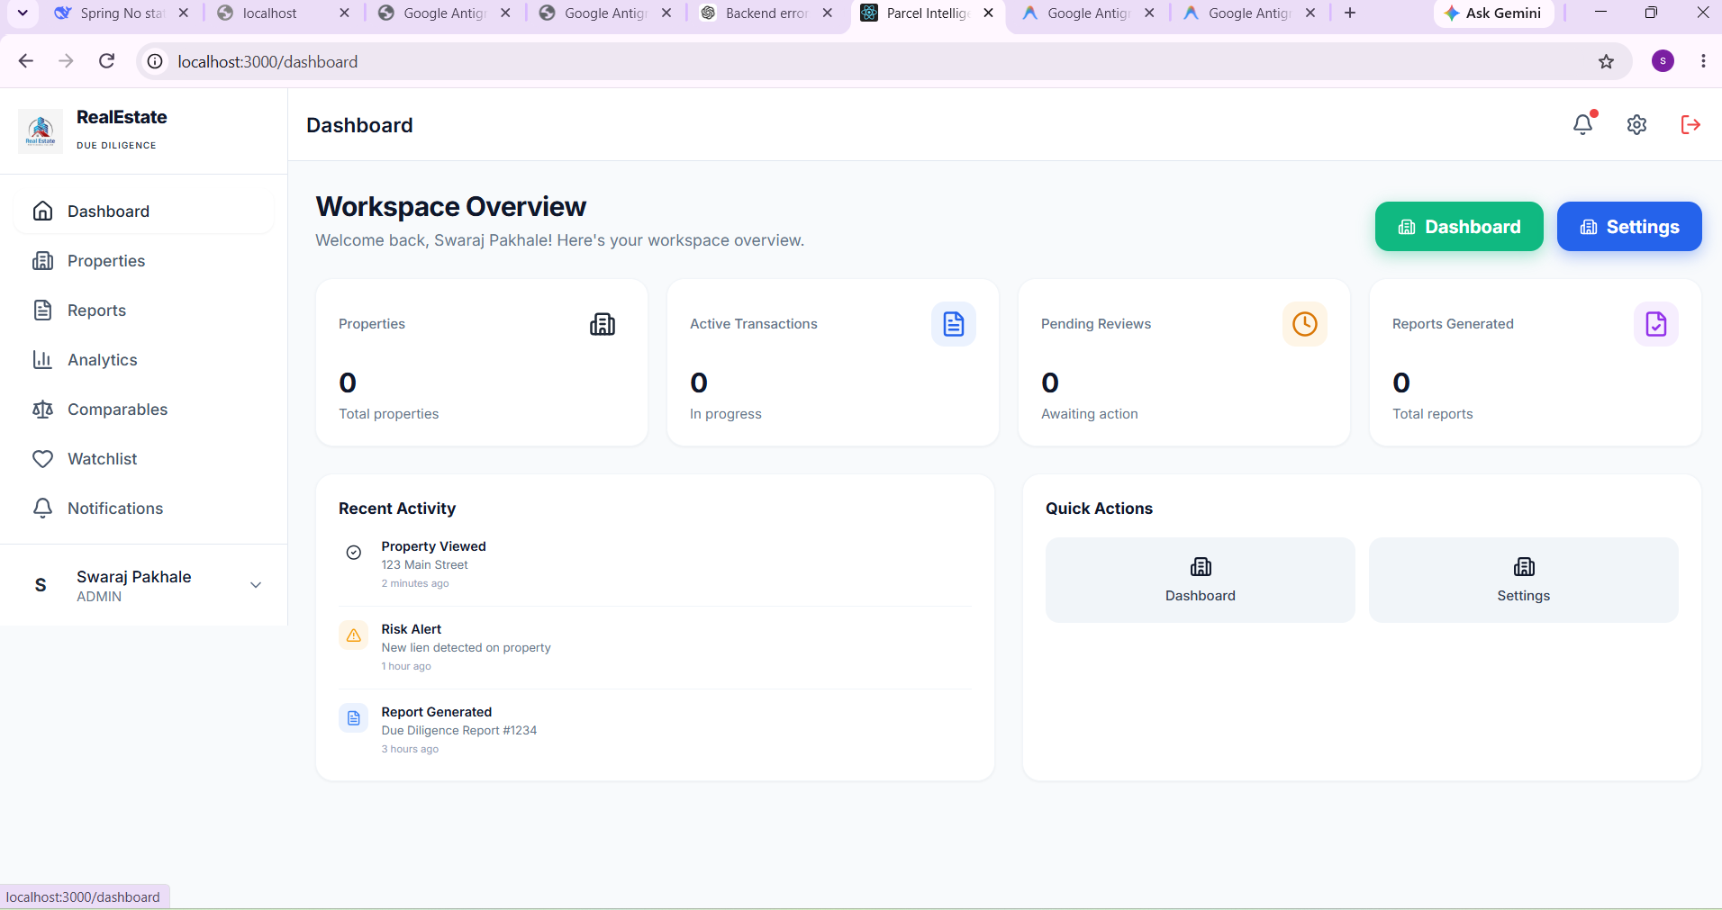
Figure 9. Report or document workflow evidence from the implemented application.

Figure 10. Export / file-management evidence used during verification.
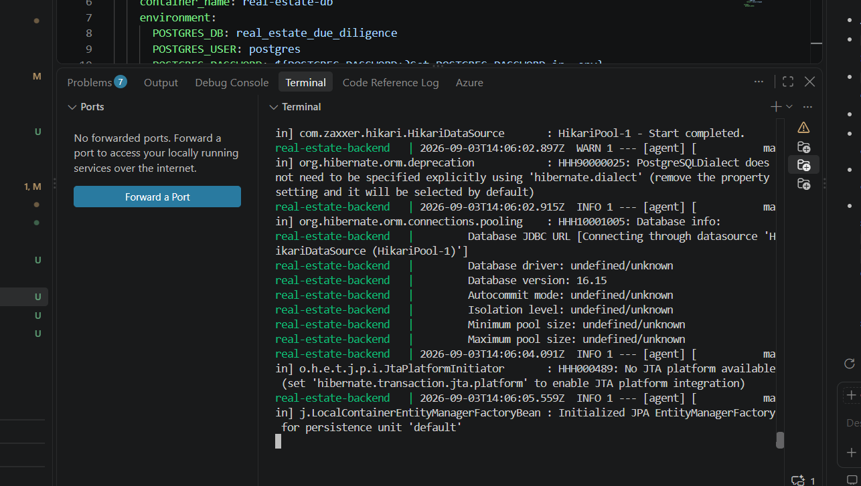
Figure 11. Backend verification / test execution evidence.

Screenshot Coverage
MENTOR REQUIREMENT | EVIDENCE INCLUDED
Dashboards | Figure 6; Figure 7
Risk Assessment | Figure 8
Downloadable / report evidence | Figure 9; Figure 10
Testing / runtime evidence | Figure 11
Authentication | Figure 5

Final Submission Summary

Evaluation Snapshot

Property Search Performance
(1) Property search response time.
(2) Address validation accuracy.
(3) Property data retrieval success rate.

External Data Integration
(1) Public-record retrieval success rate.
(2) External API response time.
(3) Data synchronization reliability.
(4) Failed API request recovery rate.

Due Diligence Performance
(1) Report generation time.
(2) Risk assessment completion rate.
(3) Property comparison processing time.
(4) Document generation success rate.

System Performance
(1) API response time.
(2) Concurrent user handling capacity.
(3) Database query performance.
(4) Cache hit ratio where caching is introduced.

Security & Audit Performance
(1) Authentication success rate.
(2) Unauthorized-access prevention.
(3) Audit log completeness.
(4) Security event monitoring efficiency.

Reporting & User Experience
(1) Report download success rate.
(2) Notification delivery success rate.
(3) User request completion time.
(4) Overall usability and user satisfaction.
TEAM ONE • REAL ESTATE DUE DILIGENCE AGENT

